NAME : Rhema Daphne E G COURSE : Mobile Computing
Reg No : 192321097 COURSE CODE: ITA0301

27.Use Figma to create an interactive presentation comparing the Core Video framework in iOS and the multimedia framework in Android.

Aim:
Create an interactive presentation comparing the Core Video framework in iOS and Android using Figma

Procedure:
- Define Presentation Structure
- Create a Figma Project
- Design Visual Elements
- Make it Interactive
- Add Annotations and Explanations 6.Incorporate Multimedia 7.Storyboard Animation
- Test the Prototype
- Collaborate and Gather Feedback 10.Finalize and Share

Design:
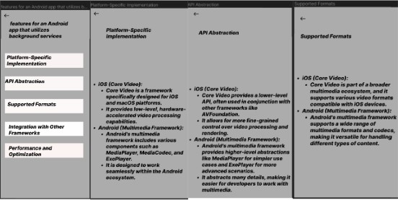

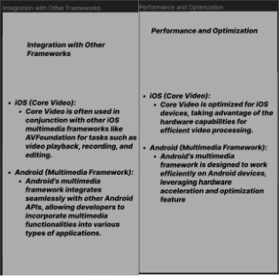

Prototype:

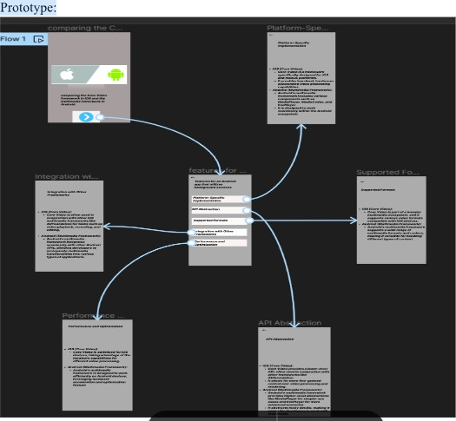

Result:
Hence an interactive presentation comparing the Core Video framework in iOS and Android using Figma have been created successfully

